(Approx. 411 words)

Marble
by Cal Esneault, Vice President, leader of many Open Source Workshops & SIGS, Cajun Clickers Computer Club, LA
December 2012 issue, Cajun Clickers Computer Club
www.clickers.org
http://cccclinuxsig.pbwiki.com
ccnewsletter (at)cox.net

Marble is free educational software from KDE that gives a virtual atlas to help students, educators, or anyone interested in geography. The most feature-rich version is provided for computers running a KDE 4.x operating system, but satisfactory versions are available for other Linux systems (QT version), Windows OS, or MAC OS. I downloaded it on my Ubuntu 12.04 system directly from the Ubuntu Software Center.

The basic map view (see below) allows you to show the earth as a globe or with Mercator or flat view projections. Simple mouse movements let you quickly change to different locations and to zoom magnification as required.

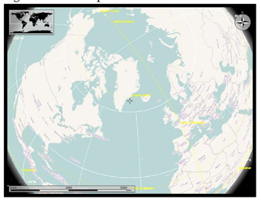

There are several different types of map views for any selected region: atlas style, OpenStreetMap view, plain map, view at night showing artificial lighting intensity, satellite views, historical map views, temperature contours (July/December averages), and precipitation countours (again for July and December). There is also a feature to determine distance between locations. At right I measured the distance between Houston and Denver (1,422 miles).

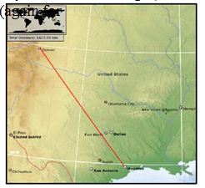

On most views you can modify the type of detail shown (for example, places of interest, political boundaries, bodies of water). Below are examples of other views. On the left is a street map of Baton Rouge, and on the right is an historical map of North America circa 1689.

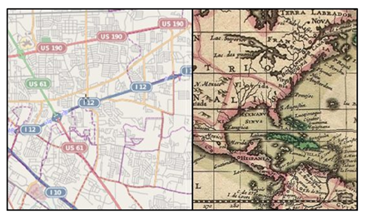

There was also a map view of our moon. Besides being able to "see" the dark side, you can also see where Apollo landings have been made. In the full KDE version, views of Mars and Venus are also available.

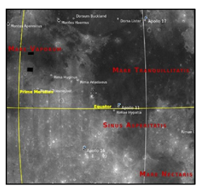

Marble may not rival Google Earth currently, but it is an important effort by the open-source community to provide simple and effective solutions which are not encumbered by DRM or other legal roadblocks. The interface is very easy to learn and is ideally suited for younger users. There is an export function that lets you copy the selected images for use with other software or for use in class assignments. Bottom line, it's fun to use and is a modern substitute for the traditional bulky atlas on the bookshelf.

Go to edu.kde.org/marble to get a free download and learn more about the Marble project. Other open-source software of interest in this area would be Stellarium (celestial maps) and OpenStreetMap (worldwide geographic data and mapping).

